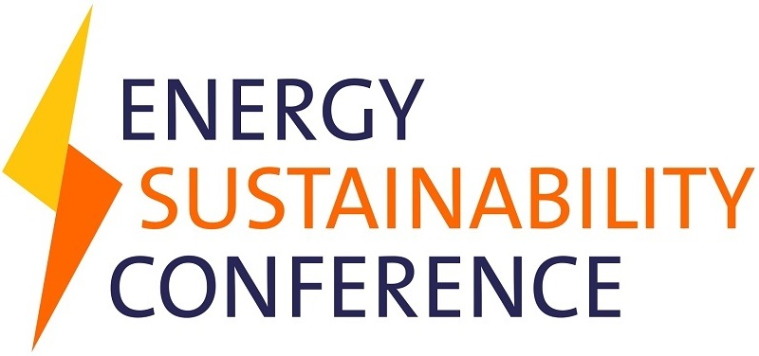
TIME | AGENDA | SPEAKER | DESIGNATION | COMPANY
09:30am – 10:00am | Registration
10:00am – 10:15am | Welcome | Mr Osten Olorunsola FEI | Chairman | EI Nigeria
10:15am – 10:30am | CEO's Address | Mrs Louise Kingham OBE FEI | Chief Executive Officer | Energy Institute
10:15am – 10:40am | Keynote Address | Dr. Lanre Babalola | Former Minister for Power
10:40am – 10:55pm | Tea break
10:55am – 12:10pm | PANEL Discussion 1 | Energy Policy & Security: Demand and supply outlook for Nigeria
 | Anchored by: | Engr Dada Thomas | President | Nigerian Gas Association
 |  | Mr Demola Adeyemi Bero | MD/CEO | First E & P
 |  | Dr David Ige | CEO | GasInvest ltd
 |  | Dr. Ndidi Nnoli-Edosien | Group Chief Sustainability and Governance Officer | Dangote group
 |  | Mr Soji Awogbade | Partner | AELEX Solicitors
12:10pm – 12:30pm | Q&A
12:30pm – 1:30pm | Lunch
1:30pm – 3:30pm | SPECIALIST SESSION: Oil & Gas Session: Nigeria post-Petroleum industry reforms.
 | Anchored by: | Mr Oluefemi Olanrewaju | Director | School of Sustainability
 |  | Mr Effiong Okon | Executive Director, Operations | Seplat
 |  | Mrs Audrey Joe-Ezegbo | Executive Director/Co-Founder | Falcon Corporation
 |  | Dr Layi Fatona | Managing Director | ND Western
 |  | Prof. Wunmi Iledare | Director of Energy Information | CPEEL
1:30pm – 3:30pm | SPECIALIST SESSION: Renewables Session: Accelerating renewables uptake in Nigeria.
 | Anchored by: | Felix Ekundayo | Chief Janitorial Officer | Asiko Energy
 |  | Prof J F K Akinbami | Director | Centre for Energy Research and Development OAU
 |  | Prof Adenikinju | Principal Investigator | CPEEL
 |  | Mr Segun Adaju | President | Renewable Energy Association of Nigeria (REAN)
1:30pm – 3:30pm | SPECIALIST SESSION: Power Session: Growing and Stabilizing Nigeria’s Electricity system
 | Anchored by: | Mr Zeal Akaraiwe | Director | Greme blaque
 |  | Mr Nasir Giwa | Vice President, Power & Gas | Siemens, Nigeria
 |  | Mrs Ivie Ehanmo | Partner | George Etomi & Partners
 |  | Rumundaka Wonodi | Founder & CEO | ZKJ Energy Inc
 |  | Gwueke Ajafia | General Manager, LNG & Technical partnerships | Total E&P Nigeria ltd
 |  | Daniel Adedokun | Head of Geocycle | Lafarge Africa PLC
3:30pm – 4:30pm | PANEL SESSION 2: Closing Session: Bringing it all together… …..in an actionable manner
 | Anchored by: | Dr. Ndidi Nnoli-Edosien | Group Chief Sustainability and Governance Officer | Dangote group
 |  | Mr Zeal Akaraiwe | Director | Greme blaque
 |  | Felix Ekundayo | Chief Janitorial Officer | Asiko Energy
 |  | Mr Oluefemi Olanrewaju | Director | School of Sustainability
 |  | Dr. Lanre Babalola | Former Minister for Power
4:30pm – 5pm | Vote of Thanks: | Mr Osten Olorunsola FEI | (Chairman Energy Institute Nigeria)
7:00pm | Cocktail reception
8:00pm | Dinner and Honorary Fellow of the Energy Institute (FEI) Conferment
 | Dinner to be hosted by NG Delta

